Benthic report card notes July 24, 2017

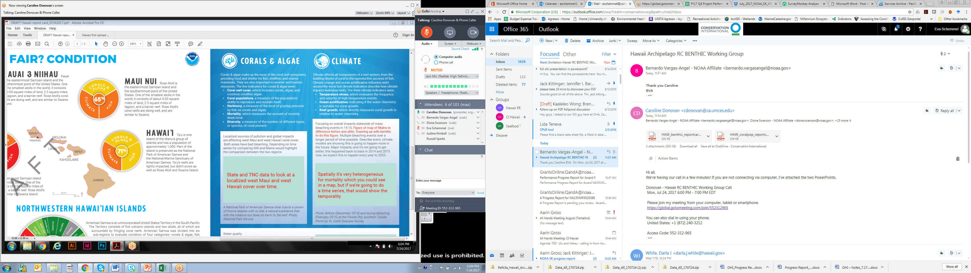

Updated to 2016 but have not yet been weighted by area

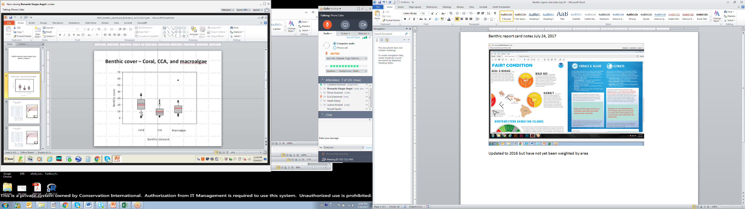

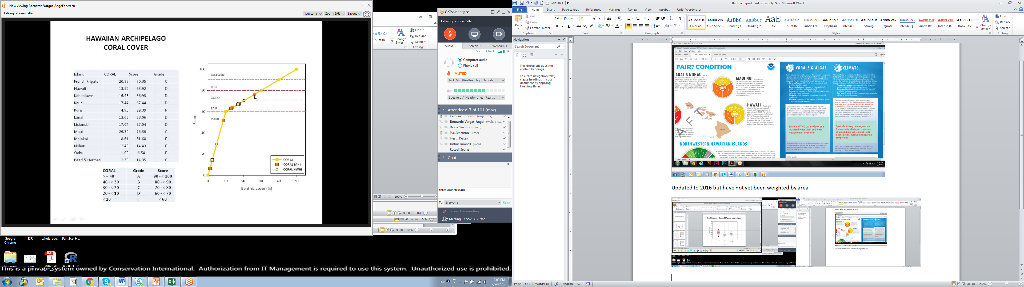

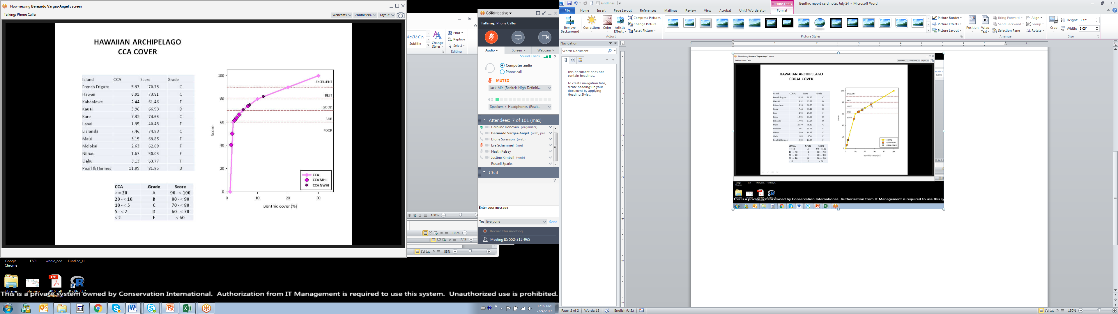

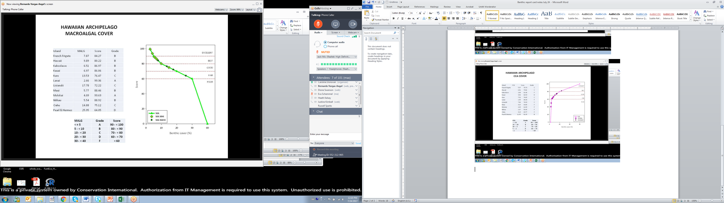

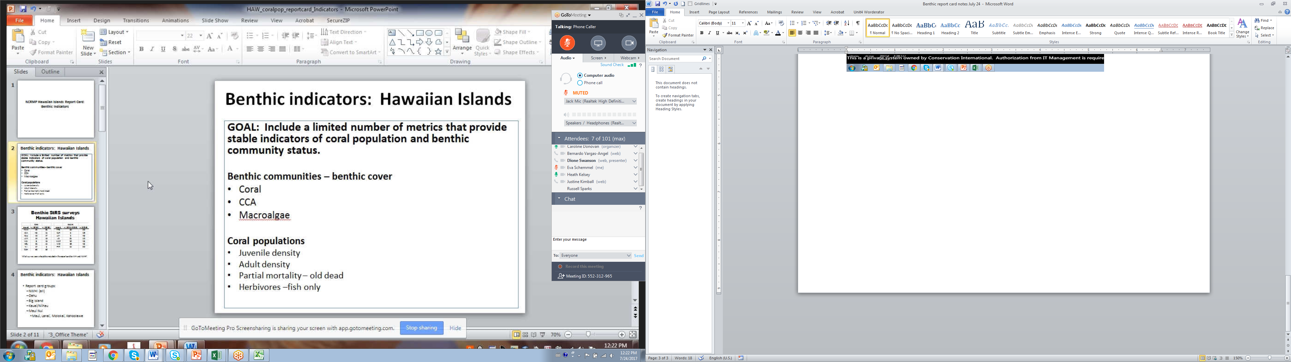

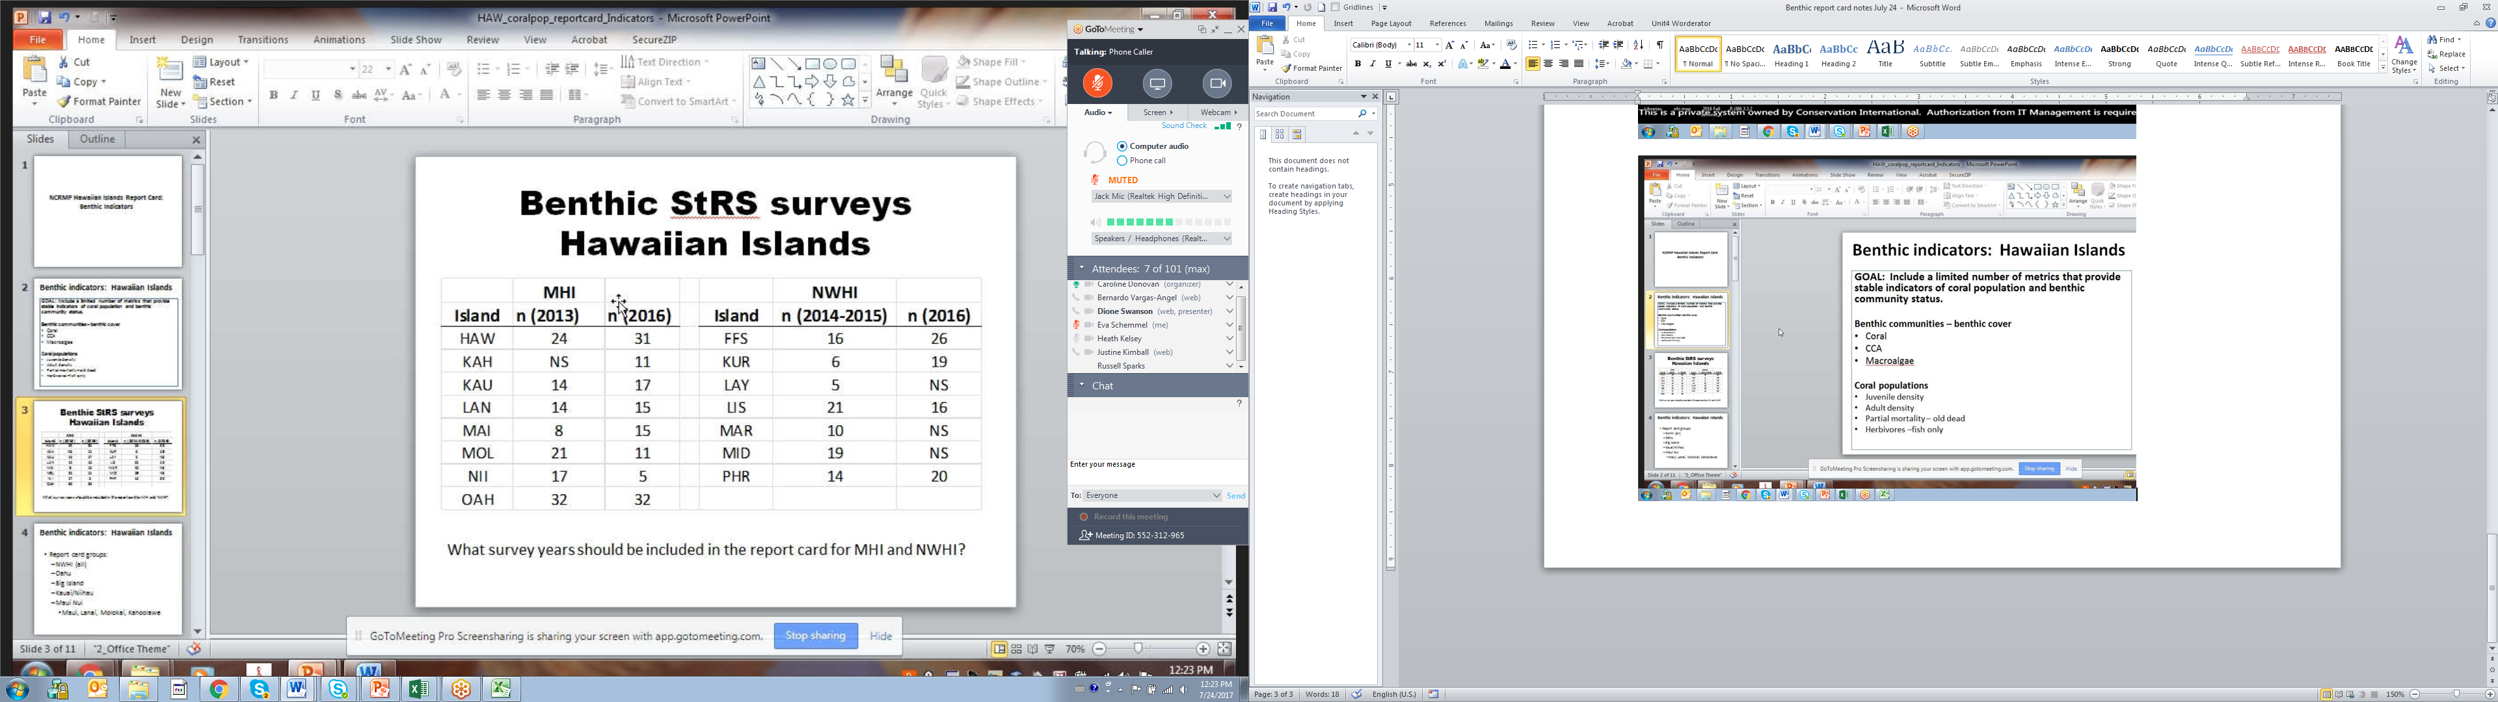

% cover data limited – some islands some years

Are we going to include 2013 and 2016 data? – use 2016 data for %cover and use time series for West Maui and West Hawaii

Generate indicators for each year and see if they make sense?

Partial mortality goes way up in 2016 data.

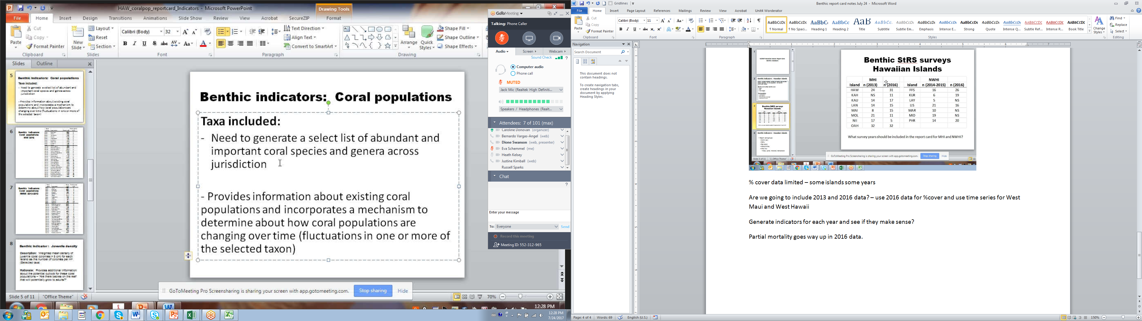

Used a list of coral species to measure against. Not all corals included but then can look and see across taxa to see if species are changing

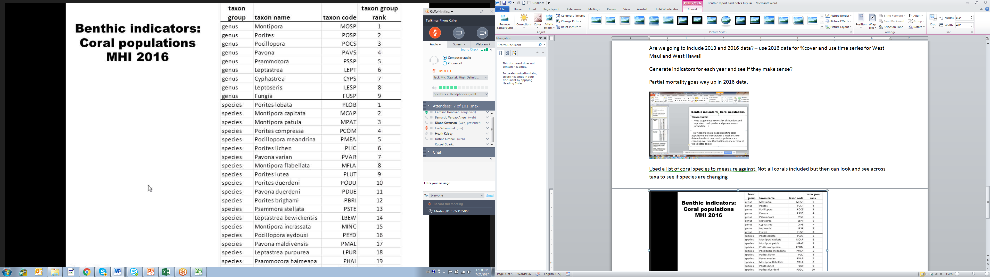

Ranked based on abundance within regions/domains up top 30 m depth – can’t always id juveniles to species level

5 genera and 10 species will likely be assessed – based on abundance

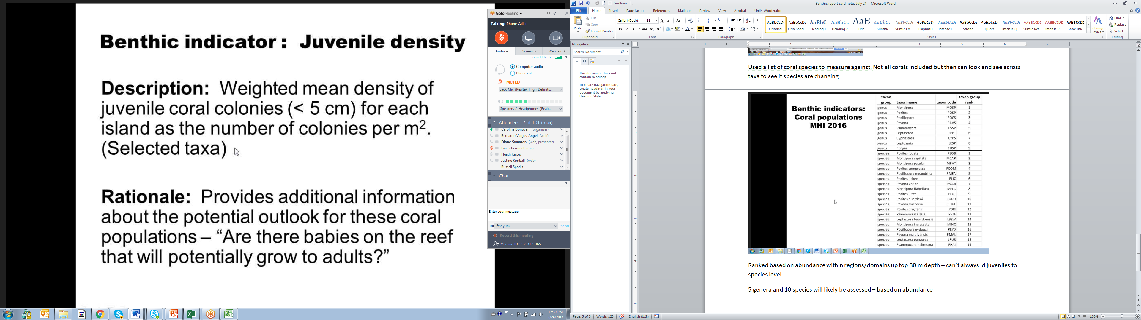

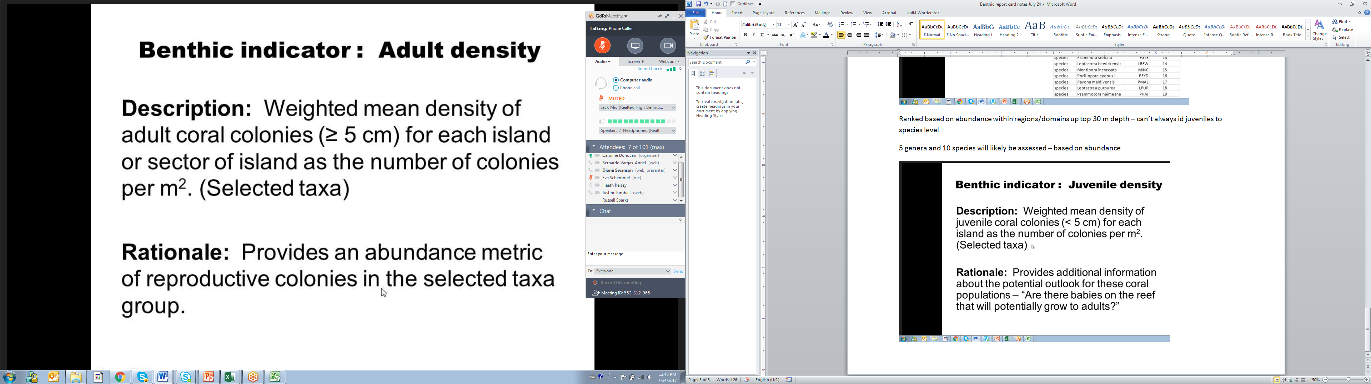

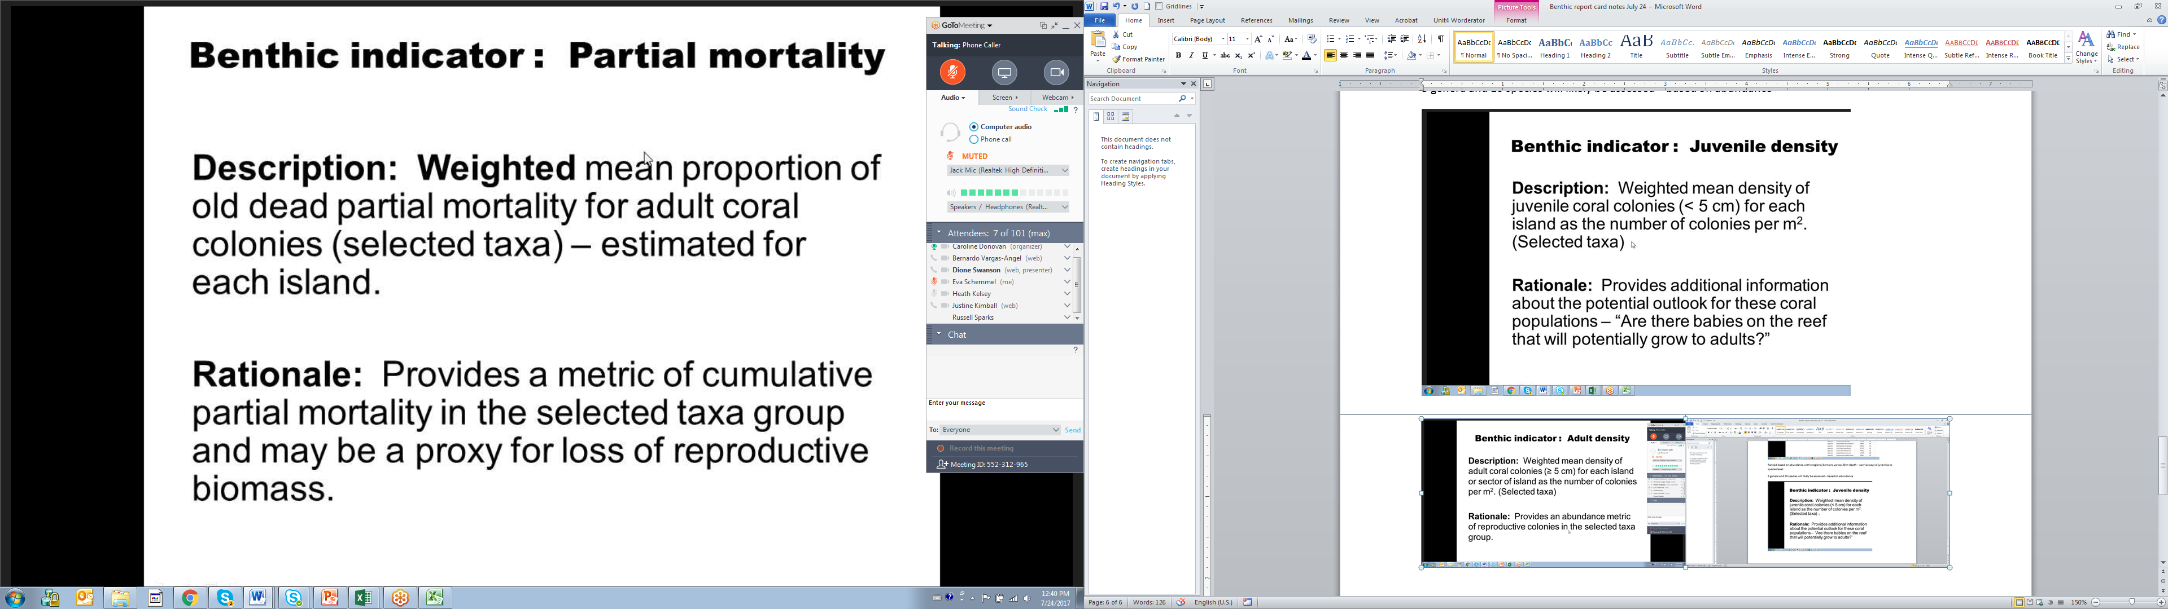

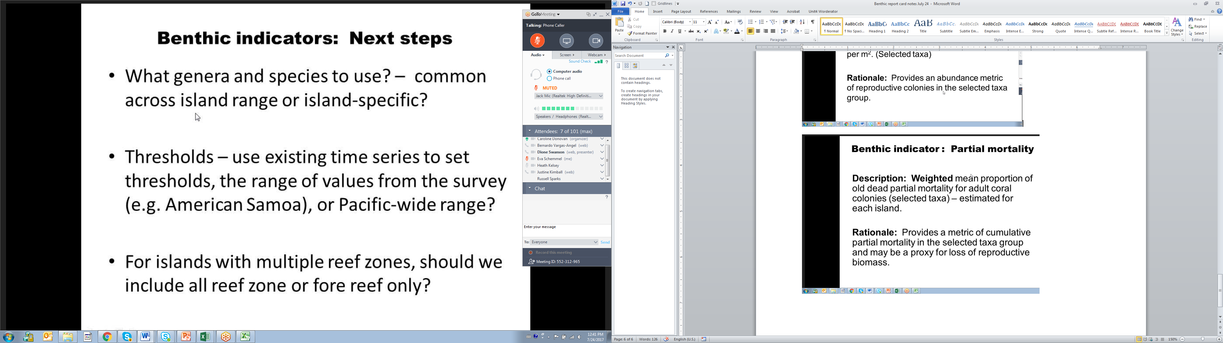

Genera groups will be specific for each island. Then indicators will be developed.

Stratified by island, reef zone, and depth – need to set references so that they are representative